**Class:** Final Year (Computer Science and Engineering)

**Year:** 2023-24 **Semester:** 1

**Course:** High Performance Computing Lab

**Practical No. 12**

**Exam Seat No:** 2020BTECS00112

**Full Name**: Meet Gandhi

**Title of practical:** Analysis of MPI Programs

**Problem Statement 1:**

Execute the MPI program (Program A) with a fixed size broadcast. Plot the performance of the broadcast with varying numbers of processes (with constant message_size). Explain the performance observed.

**Screenshot:**

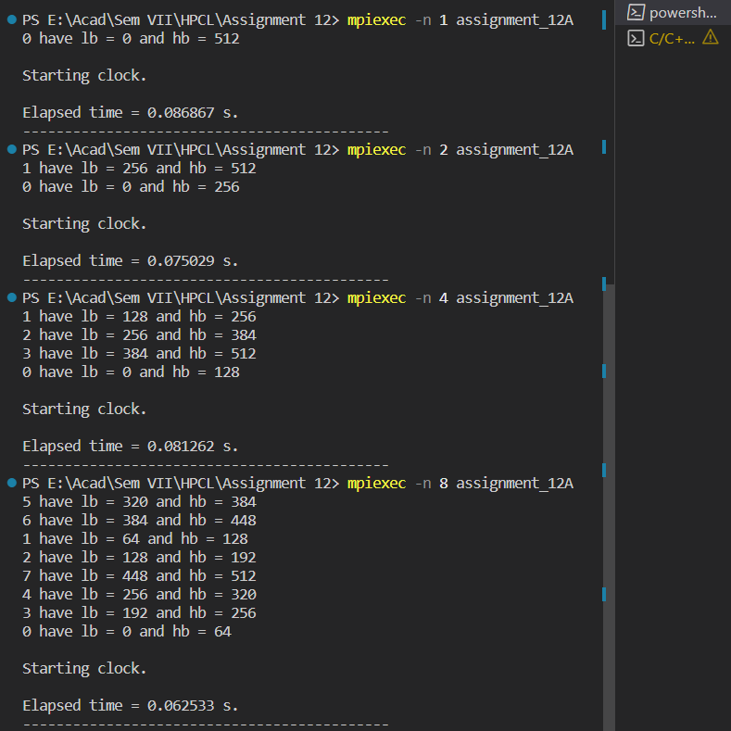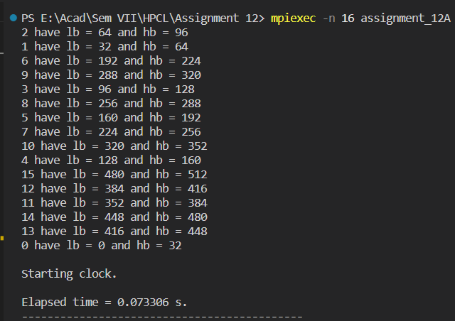

**Analysis:**

**Problem Statement 2:**

Repeat problem 2 above with varying message sizes for reduction (Program B). Explain the observed performance of the reduction operation.

**Screenshot:**

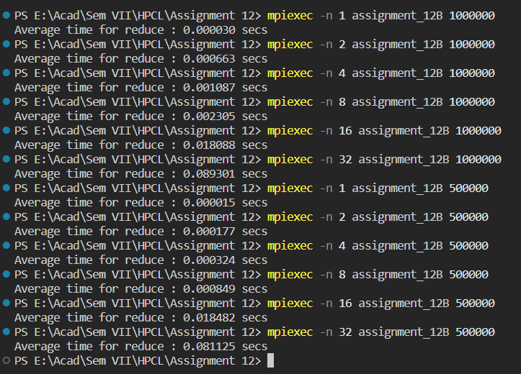

**Analysis:**

GitHub: <https://github.com/meetgandhi692/HPC-Lab/tree/9eeb3c100b78e258f402c1a575a546d518447a48/Assignment%2012>